Zoomobile Information

Booking a Zoomobile:
- All Zoomobile program requests must be submitted through the appropriate online form found on our website. Requests should be submitted at least 4-weeks prior to the preferred program date. *Requested dates and times are not guaranteed and alternative options may be provided by Zoo staff
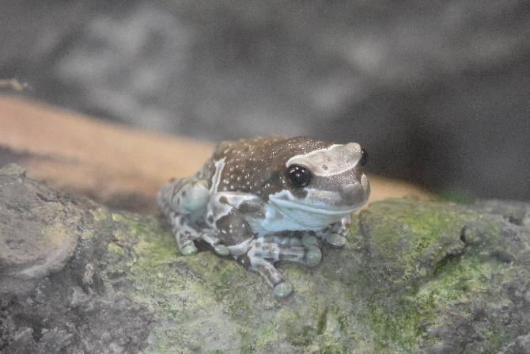
- Programs cannot take place in private residences.

Program Site Requirements:
- A reserved parking spot close to the entrance of the building.
- A stairs-free entrance to the building and program space must be available. Access to an elevator or ramp is acceptable.
- Programs must take place in an indoor climate-controlled space, apart from STEAM Tables. Please avoid spaces where other animals, other than service animals, will be present. If multiple programs are booked, please allow staff to remain in the same room throughout the visit.
- Teachers or adult chaperones must stay in the program space to ensure appropriate behavior for the safety of our animals.
- Programs require a 6-foot presentation table and room for Educators to move around the space.
- Some programs may require access to technology or have additional requirements which will be communicated during the booking process.

The Kansas City Zoo & Aquarium reserves the right to deny, defer, or cancel Zoomobile programming if there is a concern for the safety of animals, audience members, Zoo staff, and/or biofacts.

What should I expect on Zoomobile Day?
The Zoomobile will arrive at your facility about 10-15 minutes before your program start-time to allow Zoo Educators time to check in with your office, bring in any animals, and set up and technology or materials needed. Program length and activities varies based on your selected program and will be reflected in your confirmation email upon booking. Please allow longer set-up for Large Group Programs.

How can I Prepare my Group?
Our trained staff work with different audiences almost every day, so we are ready to answer questions and have fun! With that, please remind the group that to make sure our animals are comfortable and feel safe in their space, it is important to follow Zoo staff directions and use indoor voices. Participants can be assured that we bring animals into the community that are safe, and very used to being around audiences of all ages.

My facility is having trouble meeting one of the Zoomobile requirements, what should we do?
Contact us! Based on the requirement or situation, we can provide you some ideas on how to make your program work for everyone! We can be reached at education@fotzkc.org

Can I request a specific animal for my program?
For eligible programs, our team will bring animal ambassadors that are relevant to the content of the program and are appropriate for the audience. While allergies should be communicated during the booking process, we cannot guarantee that any specific animal will visit your facility.

What if we get bad weather on Zoomobile day?
Zoomobiles may be cancelled due to severe weather, or other unforeseen circumstances. Programs will be rescheduled, if possible, at the earliest convenience of both parties. If the Kansas City Zoo & Aquarium must cancel a program, staff will reach out to the site contact to notify them of the cancellation.

